**CREATION OF VIEWS AND ASSERTIONS**

CREATE TABLE BANK_EXP12(BANKCODE VARCHAR (3) PRIMARY KEY, BANKNAME VARCHAR (50) NOT NULL, HEADOFFICE VARCHAR (30), BRANCHES INT CHECK(BRANCHES>0));

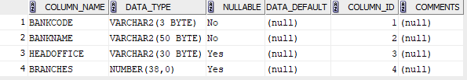

CREATE TABLE BRANCH_EXP12(BRANCHID VARCHAR(4) PRIMARY KEY,BRANCHNAME VARCHAR(50) ‘NEW DELHI',BANKID VARCHAR(3),FOREIGN KEY(BANKID)REFERENCES BANK_EXP12(BANKCODE) ON DELETE CASCADE);

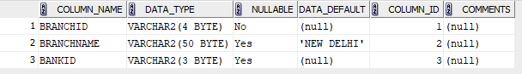

INSERT INTO BANK_EXP12 VALUES ('SBT','STATE BANK OF TRAVANCORE','KOTTAYAM',250);

INSERT INTO BANK_EXP12 VALUES ('AX','AXIS BANK','ERNAKULAM',150);

INSERT INTO BANK_EXP12 VALUES ('FB','FEDERAL BANK','KOLLAM',200);

INSERT INTO BANK_EXP12 VALUES ('SBI','STATE BANK OF INDIA','IDUKKI',50);

INSERT INTO BANK_EXP12 VALUES ('UB','UNION BANK','TRIVANDRUM',80);

SELECT * FROM BANK_EXP12;

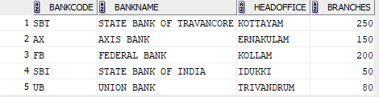

INSERT INTO BRANCH_EXP12 VALUES ('B1’, DEFAULT,'SBT');

INSERT INTO BRANCH_EXP12 VALUES('B2','KOTTAYAM','AX');

INSERT INTO BRANCH_EXP12 VALUES('B3','KOTTAYAM','FB');

INSERT INTO BRANCH_EXP12 VALUES ('B4’, DEFAULT,'SBI');

INSERT INTO BRANCH_EXP12 VALUES ('B5’, DEFAULT,'UB');

SELECT * FROM BRANCH_EXP12;

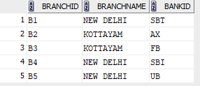

1. DELETE FROM BANK_EXP12 WHERE BANKCODE='SBT';

SELECT * FROM BANK_EXP12;

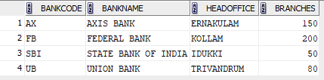

DELETE FROM BANK_EXP12 WHERE BANKCODE='SBT';

SELECT * FROM BANK_EXP12;

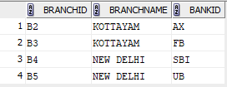

1. ALTER TABLE BRANCH_EXP12 DROP PRIMARY KEY;

DESC BRANCH_EXP12;

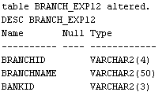

1. CREATE VIEW BANK_HEADOFFICE AS SELECT * FROM BANK_EXP12 WHERE HEADOFFICE='ERNAKULAM';

SELECT * FROM BANK_HEADOFFICE;





1. CREATE VIEW BANK_BRANCH AS SELECT * FROM BRANCH_EXP12 WHERE BRANCHNAME='KOTTAYAM';

SELECT * FROM BANK_BRANCH;



